Project Report: Meals4All

Problem Statement

Hunger and food insecurity are significant global issues, affecting over 828 million people worldwide. Meanwhile, nearly one-third of the food produced globally goes to waste. This paradox highlights the urgent need for a solution that bridges the gap between food surplus and scarcity. Meals4All was founded with the goal of tackling this dual challenge by redistributing surplus food to those in need.

Proposed Solution

Meals4All is a digital platform that connects donors (individuals, businesses, and organizations) with distribution centers, shelters, and food banks. The platform ensures that surplus food is collected, stored under hygienic conditions, and distributed efficiently to underserved communities. With features like food donation guidelines, pickup scheduling, and volunteer opportunities, Meals4All aims to make food donations seamless and impactful. Additionally, the initiative encourages monetary donations to support infrastructure and operational costs.

Conclusion

Meals4All addresses two critical issues: food waste and hunger. By leveraging technology, community partnerships, and volunteer support, the platform envisions a world where no one goes to bed hungry, and no food goes to waste.

Design Thinking Tools Used

Empathy Map

**Purpose**:

Empathy mapping was employed to understand the needs, challenges, and pain points of stakeholders, including donors, recipients, and volunteers.

**Usage:**

- Donor : Identified their primary concerns, such as ease of donation and assurance of food safety.

- Recipients : Analyzed their need for timely delivery and quality of food.

- Volunteers : Highlighted their interest in meaningful participation and clear roles.

Insights from this process informed the development of user-friendly features like clear donation guidelines, transparent operations, and accessible volunteer opportunities.

Prototyping

**Purpose**:

Prototyping allowed the team to create a mockup of the platform and test its usability with stakeholders.

**Usage**:

- Low-fidelity prototypes were developed to simulate the user flow for donating food, volunteering, and accessing resources.

- Iterative feedback from users helped refine the interface, ensuring simplicity and efficiency.

Prototyping ensured that the platform met the diverse needs of its users while minimizing development costs.

## 3. PPT of the Solution

- **Content:**

1. Title Slide: "Meals4All – Bridging Hunger and Surplus."

2. Problem Statement: Hunger and food waste statistics.

3. Proposed Solution: Key features of the Meals4All platform.

4. Design Thinking Tools: Empathy mapping and prototyping.

5. Impact: Number of meals distributed, volunteers engaged.

6. Call to Action: Join us in making a difference.

- The PPT is included in the submission as a separate file.

Snapshots of the Demonstrated Solution

1. Home Page:

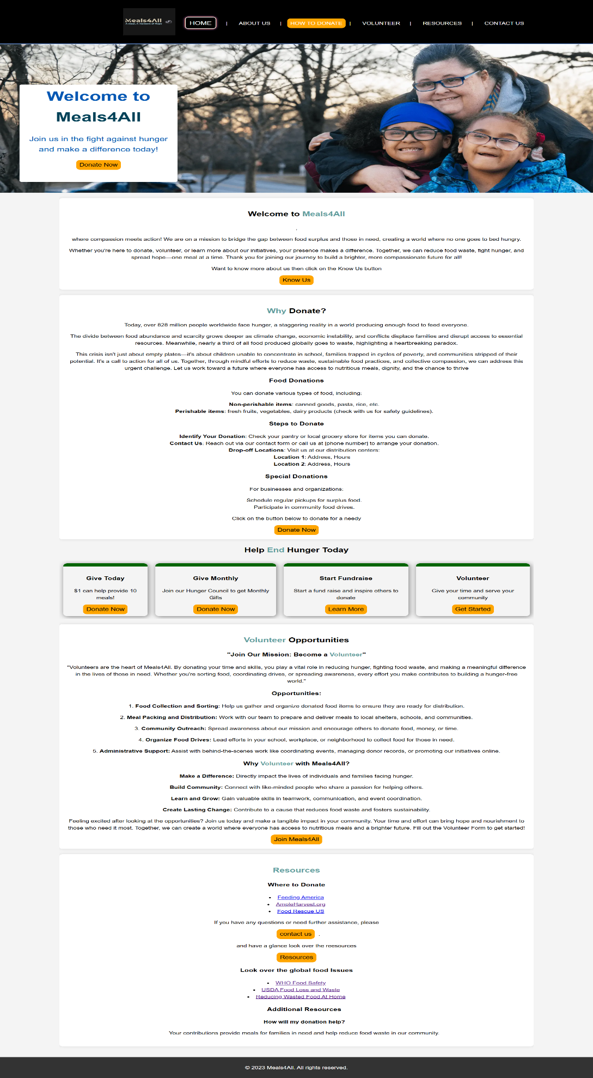

1. Donation Page:

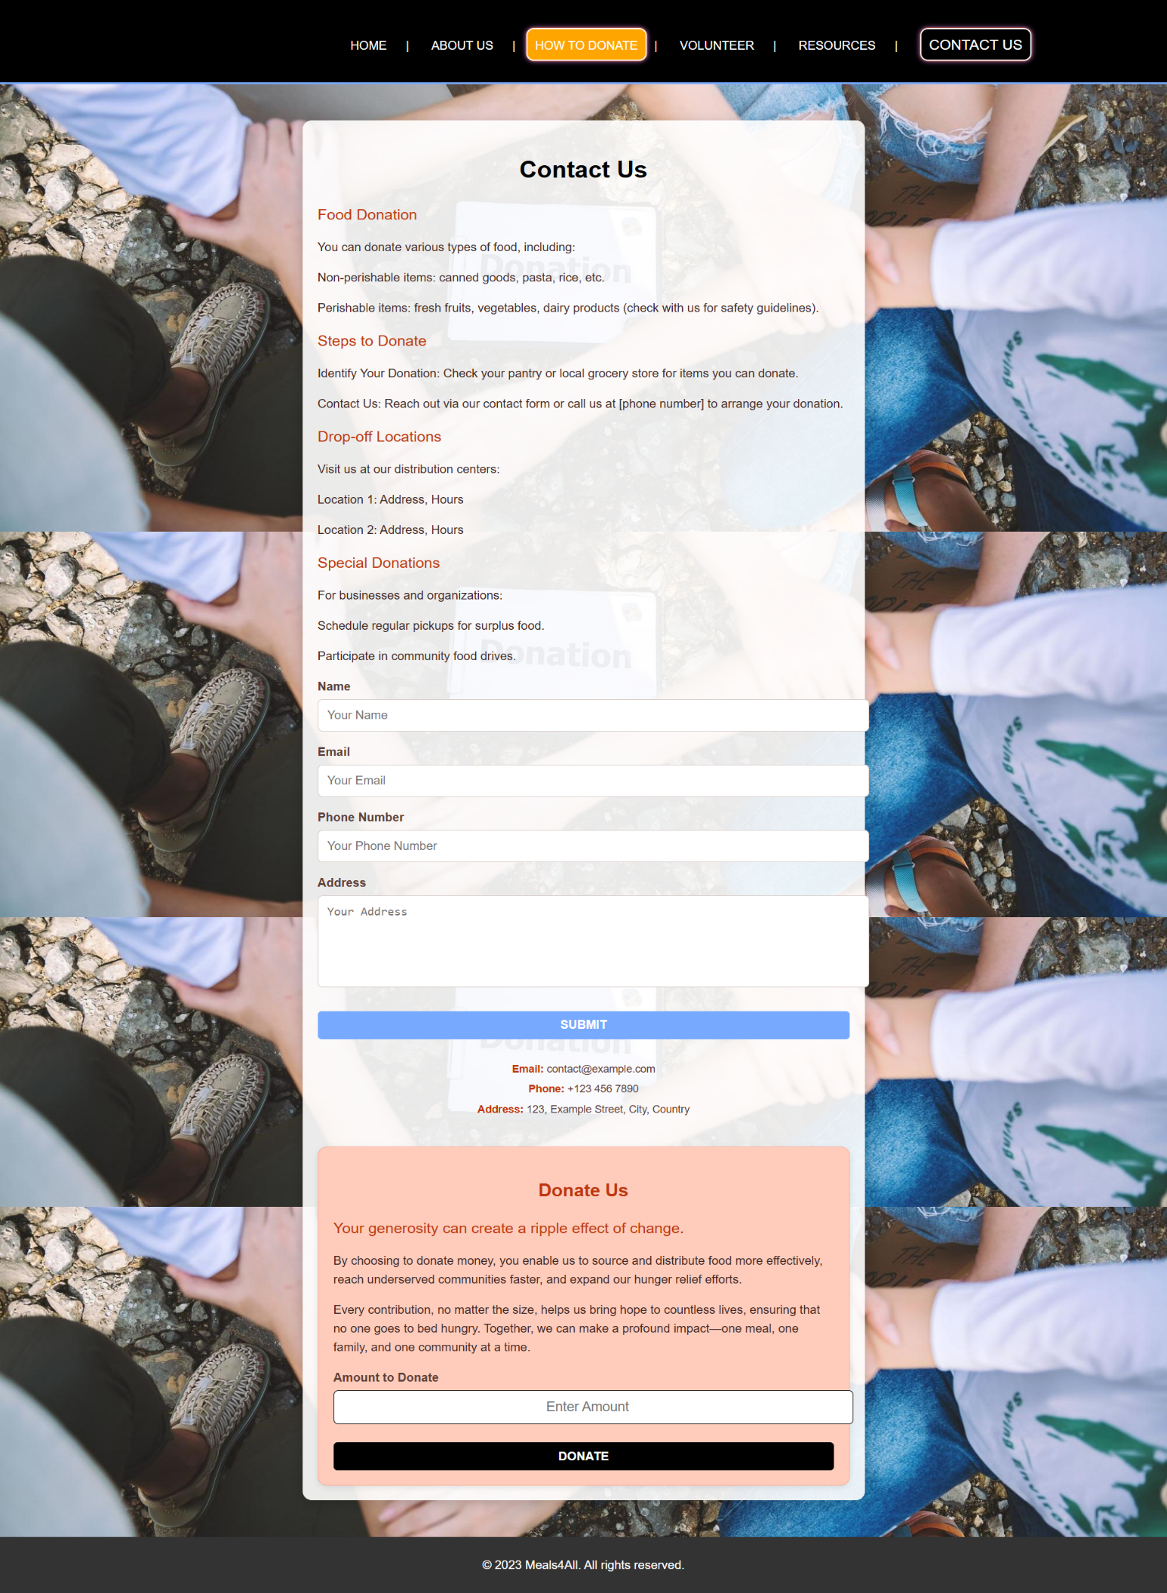

1. About Us Page:

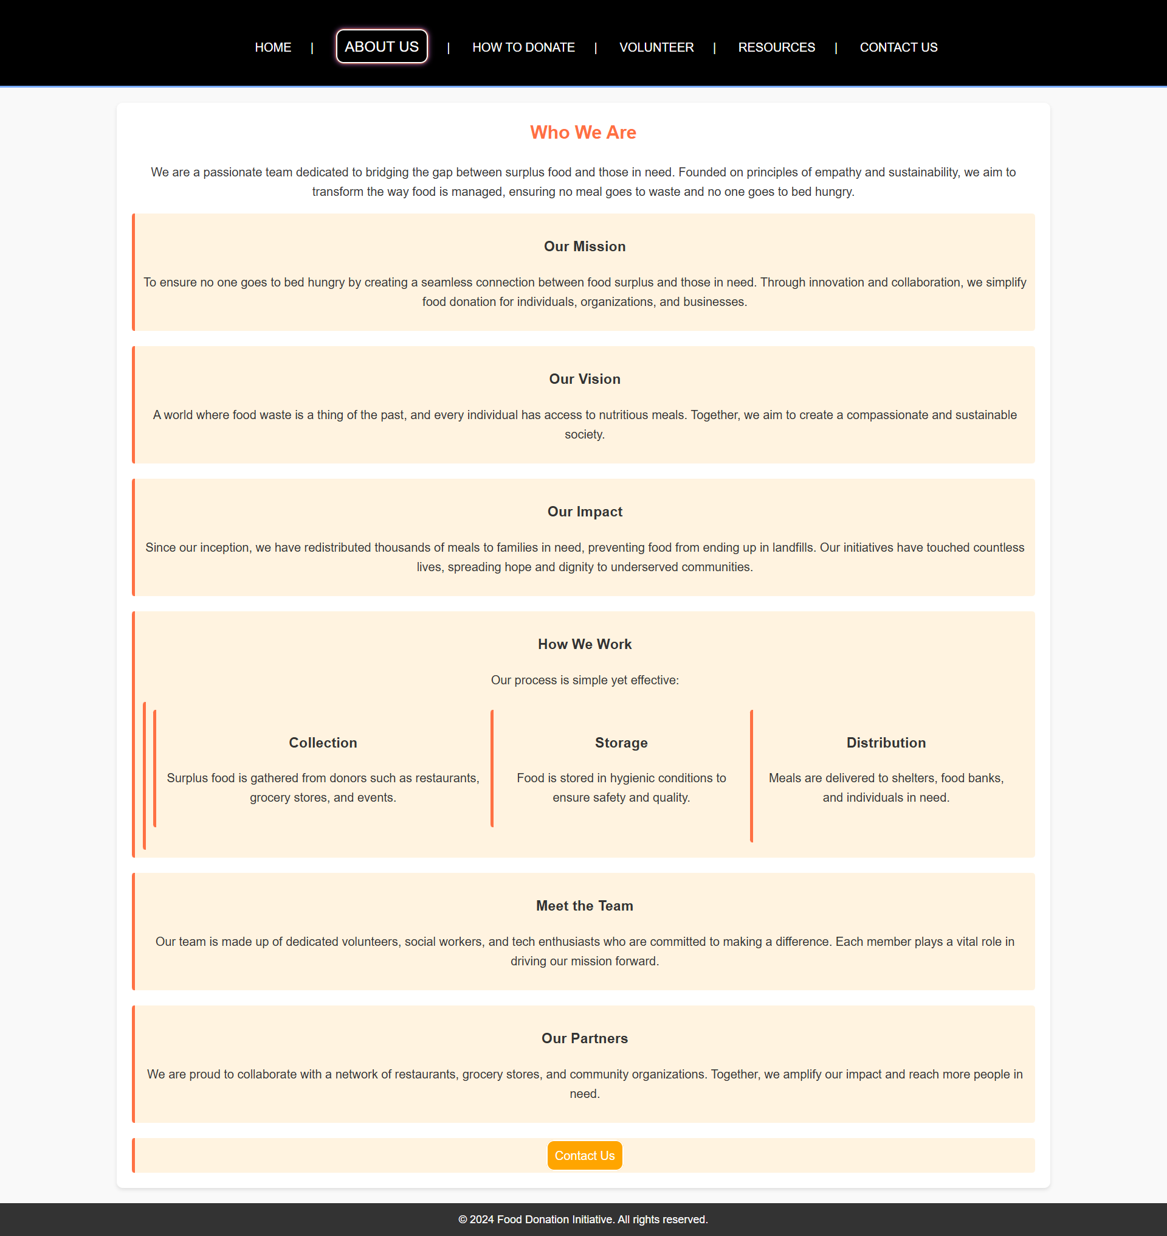

1. Resources Page

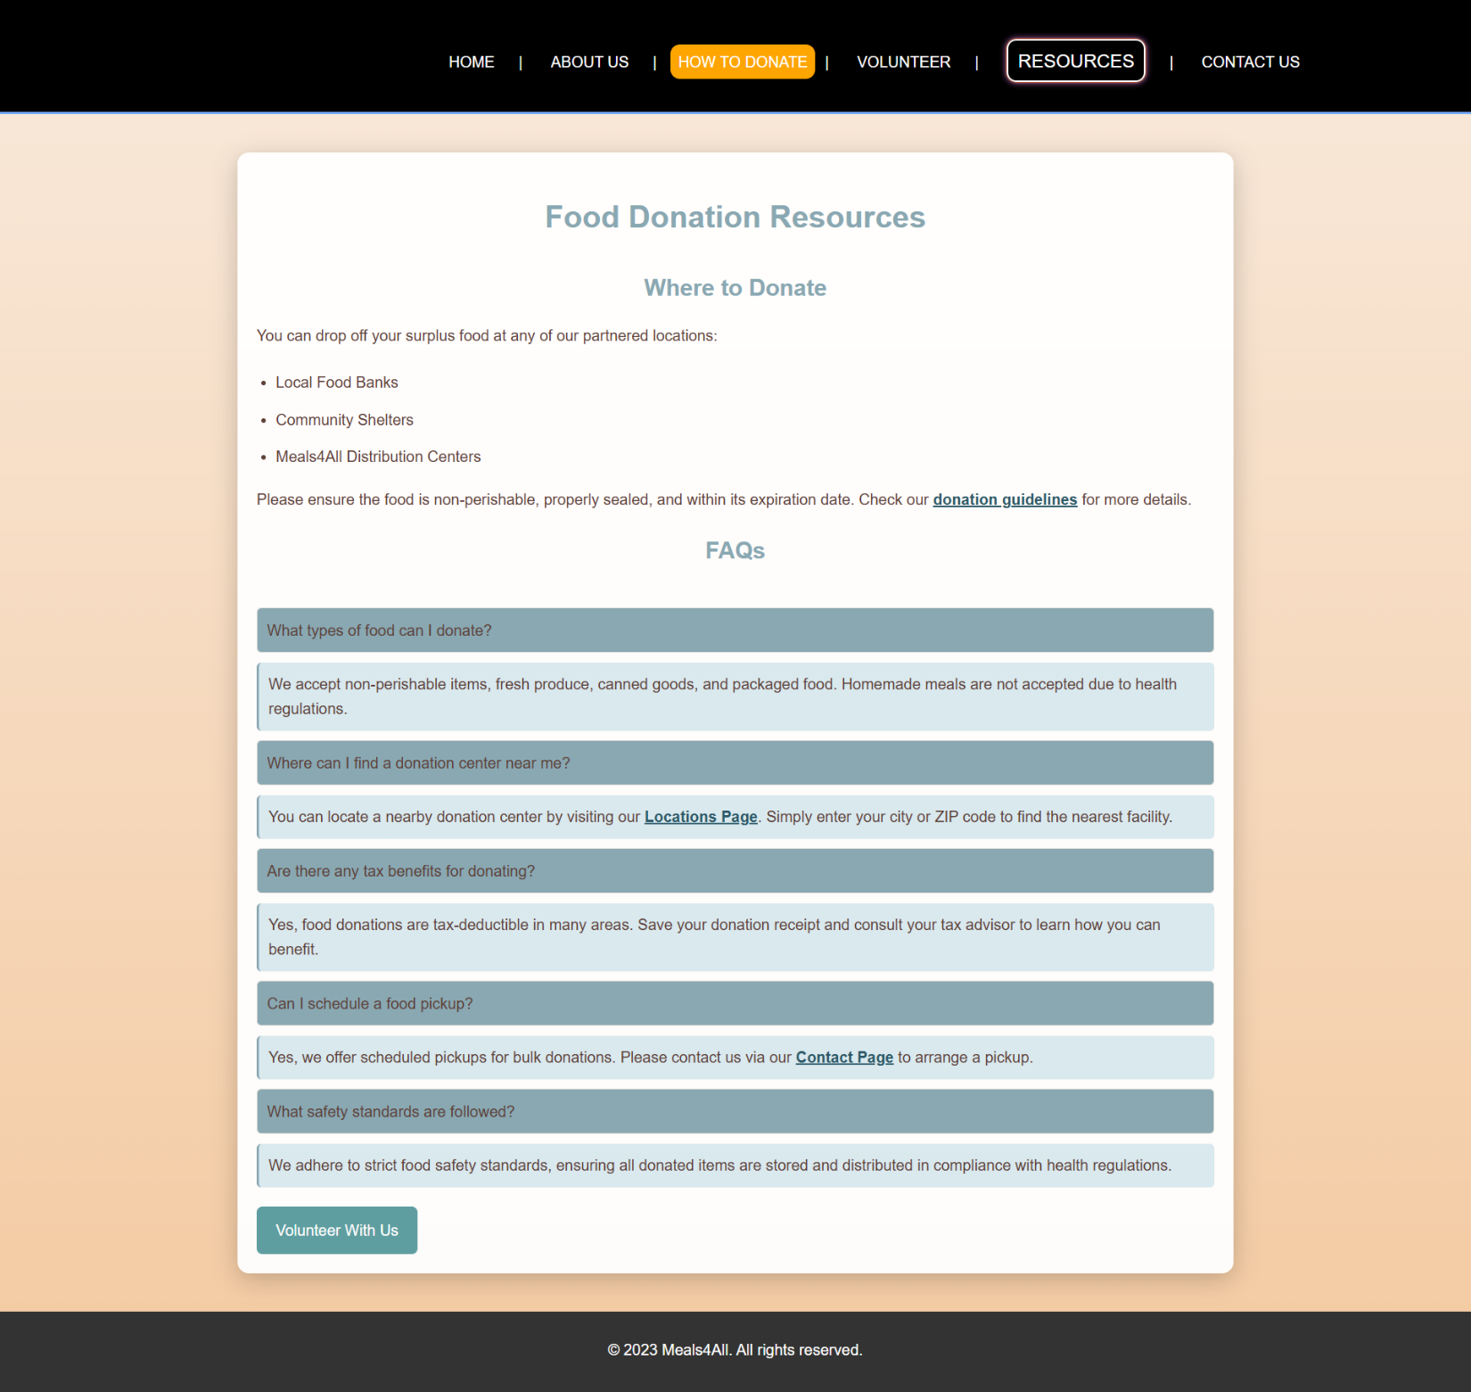

**Snapshots of Meals4All visually demonstrate the platform's usability and scope.**

### **Acknowledgment**

Meals4All is made possible through the dedication of volunteers, donors, and community partners. Together, we are creating a more sustainable and compassionate world.

**Submitted by:** Meals4All Team